**SMART STAR EXAMINATIONS BOARD**

**END OF TERM ONE EXAMINATION - 2024**

**SOCIAL DEVELOPMENT**

**BABY CLASS**

My name is………………………………………...

1. **Shade mother and father.**

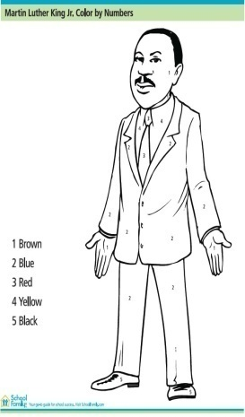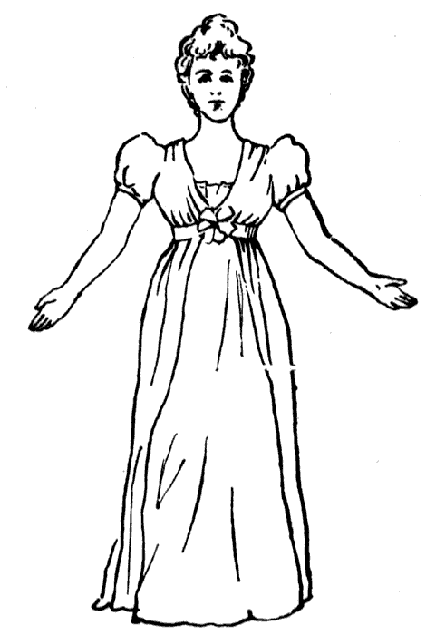

1. **Trace your home**
2. **Colour me well.**

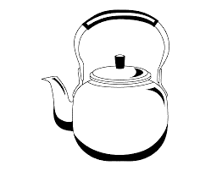

**4. Read and match people at home**

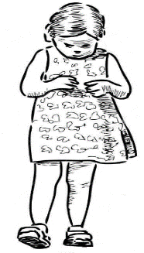



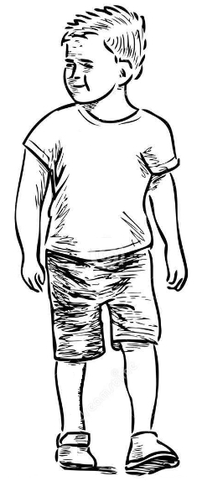







1. **Tell the picture**

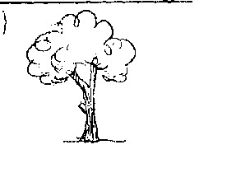

***NICE HOLIDAY***